

|  |  |  |  |  |
| --- | --- | --- | --- | --- |
| Anvesh Muttavarapu Bhargavi Chunchu Sarat Tadi |  |  |  | Z1782619  Z1781266  Z1778927 |

Kuber Investments

Application Design Document

Table of Contents

1. Description of Business 5

Mission Statement

1. Project Requirements 5

Functional Requirements

Non Functional Requirements

1. Use Case Diagrams 6
2. Wireframes 9

Login Page

Register Page

Payment Page

Home Page

Cash Buy functionality page

Order Summary Page

# Description of Business

|  |  |
| --- | --- |
|  | Kuber Investments is an investment platform to trade and invest in stocks online, seamlessly. |

## Mission Statement

|  |  |  |  |
| --- | --- | --- | --- |
|  | Our mission is to empower individual investors to take control of their financial lives, free from the high costs and conflicts of traditional brokerage firms |  |  |

# Project Requirements

## Functional Requirements

* Login – Investor logs into the system by entering the username and password.
* Register – Registers as an investor by providing the basic details and creates a login.
* Payment – Processes payment with the investor card details provided.
* View transactions – Displays the list of transactions performed by the investor.
* Cash Buy – Buys the stock.
* Cash Sell – Sells the stock.
* Margin Buy – Buys the stock with margin.
* Margin sell – Sells the stock with margin.
* Online Chat – Customer service support for the queries from the investors.

## Non Functional Requirements

* Performance: The system must handle 1000 transactions per second.
* Reliability: Integrity of the information maintained and supplied to the system.
* Security: Efficient encryption mechanism in order to protect customer data.
* Mobile: The application must be mobile compatible.
* Portability: Application must be compatible on different platforms.
* Redundant: Data must be stored and secured at multiple locations.
* Scalability: The Application will remain effective with increase in number of users and resources.
* Legal Compliance: Application must be compliant with legal issues involving intellectual property rights and privacy of information.

# Use Case Diagrams

# Wireframes

## Login Page

# 

## Register Page

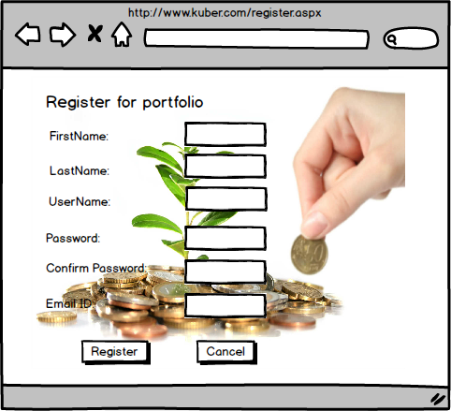

## Payment Page

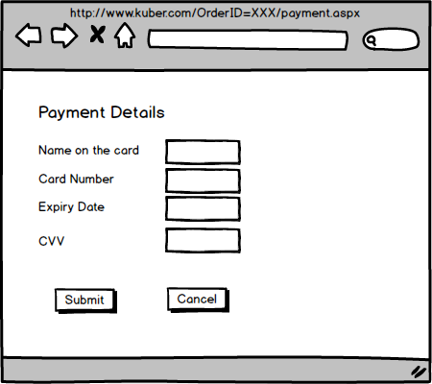

## Home Page

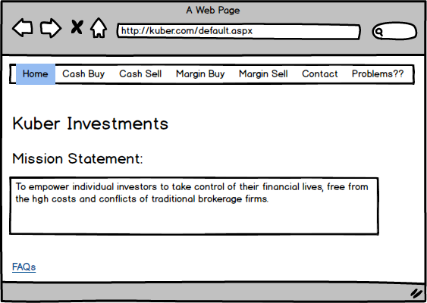

## Cash Buy functionality page

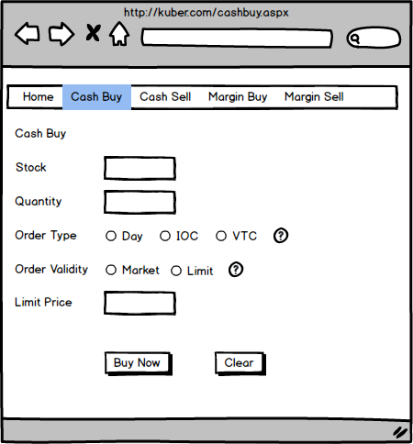

## Order Summary Page

